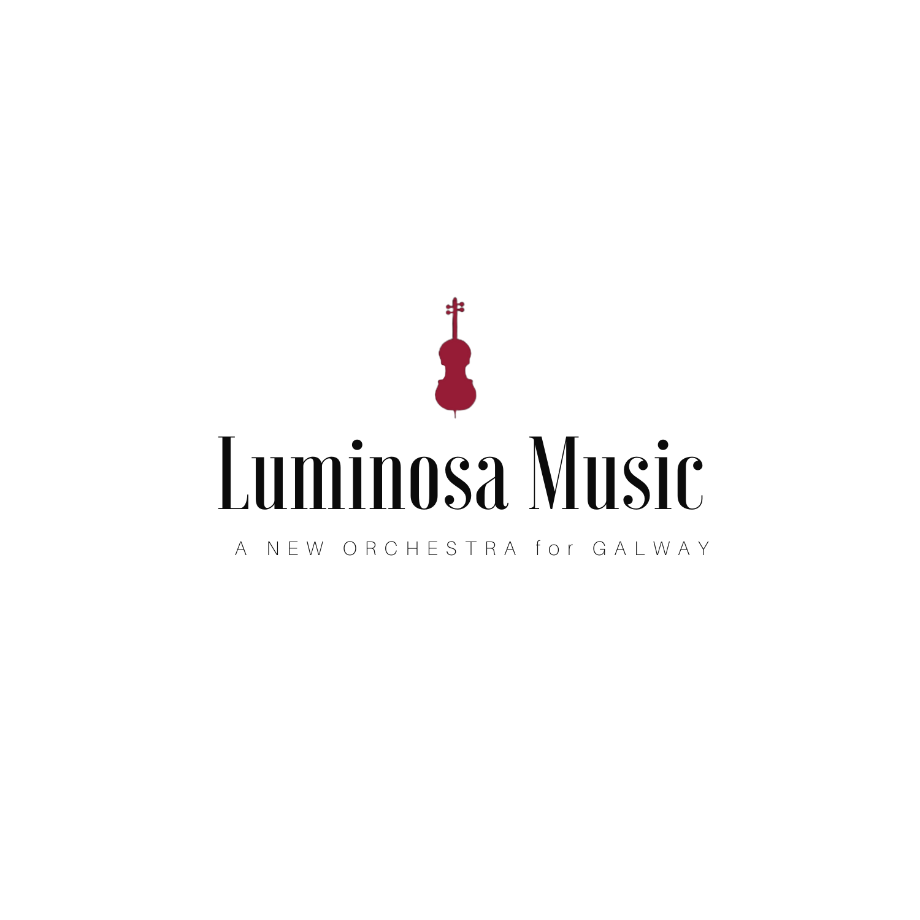

Auditions 2022
Orchestral Excerpts List

Violin
1. Mozart Symphony 39 4th movement - Exposition to letter A; or
2. Elgar Enigma Variations - Variation 2

Viola
1. Mozart Symphony 35 Presto (bar 134- reh E); or
2. Mendelssohn Ein Sommernachtstraum Scherzo (bar 17 to reh D)
Cello
1. Mozart Overture to The Marriage of Figaro (Presto to bar 24); or:
2. Smetana Bartered Bride (until 5 bars after reh A)
Double Bass
1. Mozart- The Marriage of Figaro Overture (start to bar 24); or:
2. Beethoven -Symphony no 7, first movement (start to reh C)

Find and download excerpts at:

http://orchestraexcerpts.com/

